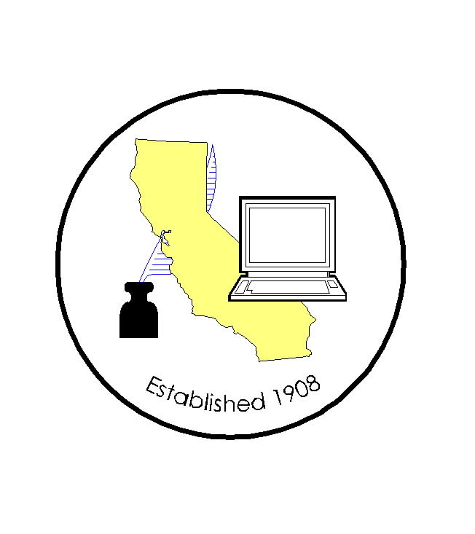
CALIFORNIA ASSOCIATION OF

CLERKS AND ELECTION OFFICIALS

DATE: December 17, 2009
TO: CACEO Members, Legislative Committee
FROM: *Neal Kelley, Orange County Registrar of Voters
SUBJECT: CACEO LEGISLATIVE COMMITTEE MEETING

DATE: Friday, January 15, 2010

TIME: 9:00 a.m. – 3:00 p.m.

LOCATION: San Diego County Administration Building
1600 Pacific Highway, 7th Floor
Tower 7 Conference Room
San Diego, CA 92101

SUBCOMMITTEES: Thursday, January 14, 2010
(contact Subcommittee Chairs for additional information)

REGISTRATION
(Registration deadline: January 8, 2010)

Name: ____________________________________________________

County/City: ____________________________________________________

Fee enclosed: Member $35.00 (payment received by Jan 8)
$70.00 (payment received after Jan. 8)
Auditor cutting check
$210.00 (payment for year; due Jan. 8)

Non-Member: $105.00 (payment received by Jan. 8)
$155.00 (payment received after Jan. 8)

Check payable to: California Association of Clerks and Election Officials

*Return to: Neal Kelley, Orange County Registrar of Voters
P. O. Box 11298
Santa Ana, CA 92711-1298
phone: (714) 567-7620
fax: (714) 567-7627
e-mail: linda.strickland@rov.ocgov.com

